5

MIN READ

November 22, 2024

* [ASA updates](https://www.asauthors.org.au/news/category/asa-updates/), [Guest article](https://www.asauthors.org.au/news/category/guest-article/)

Ann James accepts 2024 ASA Medal

*On 13 November 2024 at the ASA’s Colin Simpson Memorial Keynote event in Sydney, Ann James was presented with the ASA Medal. Below is a transcript of Ann James’ acceptance speech, as well as an introduction by ASA Board Director, Dub Leffler.*

Introduction by Dub Leffler

The ASA Medal is awarded annually to an Australian author or illustrator who has made an outstanding contribution to Australian culture as both a creator and an advocate. Previous recipients of the Medal include Anita Heiss, Thomas Keneally, Helen Garner & Bruce Pascoe. Which brings me to this year’s recipient, Ann James.

Ann Catherine Stewart James has illustrated over 60 books for children, as well as writing several of those herself. She is known for such titles as *Lucy Goosey*, *The Midnight Gang* & *I’m a Dirty Dinosaur*, among others.

Coupled with Ann’s amazing back catalogue, it is Ann’s tireless advocacy work and mentorship that sets her apart, making her so deserving of this Medal. From creating Books Illustrated in 1988, a hub & an exhibition space to promote Australian illustrators, and then co-founding The Society of Book Illustrators the same year, to helping to establish the Hello! from Australia Publishing Collective Stand at the Bologna Book Fair in Italy (the largest Children’s Book Fair in the World!), to then helping facilitate the merger of The Society of Book Illustrators with the ASA, Ann went on to serve as an ASA Board Director for 20 years, representing the interests of illustrators across the country.

Ann is the very first illustrator in history to receive the ASA Medal!

Can I tell you a story?

About 25 years ago,  I saw an ad in the paper – it was from Books Illustrated, and they were looking for Indigenous illustrators – so I applied.

Shortly thereafter, I received a lovely handwritten letter written on yellow paper, and it began, ‘written on the last day of summer’.

It was from Ann. She wrote that she liked my portraits & that I should try illustrating my own version of an existing book title’s cover.

Now that letter was my very first connection with the publishing Industry. Thank you, Ann, for making it a pleasant one.

My story is one of many about Ann. Ann, you have given so tirelessly of yourself in the pursuit of helping promote Australian book creators to the world. And on behalf of all those people – we thank you.

It is with great pleasure that we bestow this years’ ASA Medal unto you, Ann James.

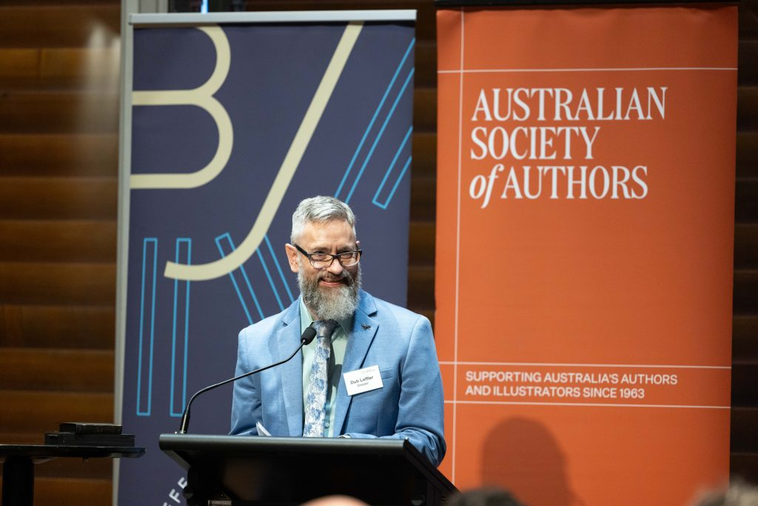

Ann James’ acceptance speech

I’m overwhelmed and humbled – but thrilled as a beetle as my Dad would say – to accept the ASA Medal, as it recognises illustrators as authors and celebrates the collective achievements of Australian and children’s book creators.

Thank you, ASA, for this honour.

Front and centre on the ASA website is this statement ‘We stand behind creators. The ASA is here for all Australian writers and illustrators – aspiring, emerging and established.’ This statement of support including illustrators, would not have been considered when our Australian children’s book industry was getting started in the 1960s.

The ASA also now points out on their website that ‘while Australia’s storytelling heritage spans many millennia, our publishing industry is young and shaped by colonialism’. Those interested in art, illustration and story at that time were inspired by overseas literary styles and traditions.

Many of our novels written by Australian authors at that time were published in the UK and often illustrated by UK illustrators. A favourite of mine, *Tangara* by Nan Chauncy, was illustrated by Brian Wildsmith. His illustrations intrigued and inspired me, even at 9! Of course, the importance and impact of illustration and picture books for children from other countries was well accepted but there was a growing number who were keen to ‘grow our own’.

In 1978, probably encouraged to find more Australian new gems like *John Brown Rose and the Midnight Cat*, the Margarita Webbers Bookshop in Melbourne advertised a competition for unpublished picture books in *The Australian*. Entries poured in and over 300 manuscripts with dummies and original art were pawed over by Bob Sessions and other keen publishers. They discovered new creators including Graeme Base, Jane Tanner, Terry Denton, Alison Lester and me amongst the mix. Books were published and lots of careers took off. And we discovered each other and revelled in our shared love of telling story in words and pictures. So, it’s 45 years since I illustrated *A Pet for Mrs Arbuckle* – my first book, and it’s 36 years since Jess (Ann Haddon) and I opened Books Illustrated, our little gallery for book illustration. The sort of dream a teacher librarian and an art teacher would dream up together in 1988 – a gallery to celebrate the artists and the art of Australian children’s books in a little cottage in South Melbourne.

With only one course in Australia for book illustration, collaboration became the uniting force. At one gathering, discussing projects that we’d been offered by publishers, we discovered that several of us had been offered the same text at the same time! And, without knowing much about what we were doing, we established SOBI, The Society of Book Illustrators. It quickly developed into a support group by and for illustrators – and was gradually respected by publishers. In 1996 the ASA agreed to take this illustrator riff raff on and the rest is history. Soon there were many artists interested in the field of picture book illustration – wanting to get their ideas and work seen by publishers. So, Jess and I organised a pile of folios and called it [The Style File](https://asastylefile.com/), filled, in alphabetical order, with examples of artwork for visiting publishers to look through. Now of course, it’s one of the fabulous services offered on the ASA website.

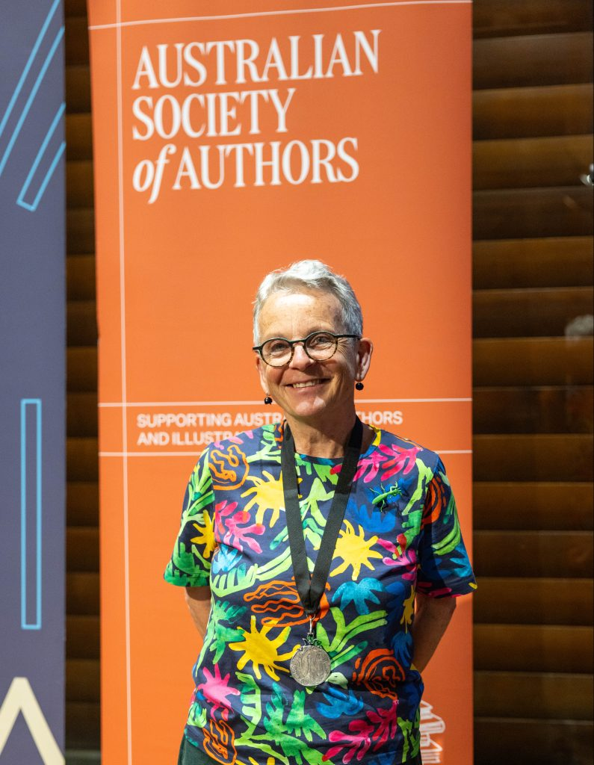

Publishing books for children has developed as a mainstay of the publishing industry in Australia and our standing around the world has grown strongly.

Story is at the heart of what we all do and the potential of the myriad directions it can and will take is already exciting – the possibilities of ways to create and experience story is growing exponentially, including, of course, the use of AI.

But I strongly believe in the uniqueness of the physical book, especially for the very young. It is a form that’s perfect for sharing. Like live music. Like theatre. And the picture book is not about learning to read. It’s about loving to read. When you share a picture book with a child you and they are using all your senses. It’s an intimate thing like singing together, cooking together, eating together. You are creating the story together at your own pace, you can turn pages back and forth, skip to the end then back to the middle. Read together. Repeat words. Ask questions. Touch the pictures and talk about them. Stop and have a chat or a cuddle.

The Indigenous Literacy Foundation agree –publishing beautiful picture books by children and elders from remote communities, telling their own stories with pictures and words to share with children and elders in other places. They’re going great guns – this year the ILF won The Astrid Lindgren Award! And a different case for the importance of physical books.

We know our future is built on learning from our history – so a plug for keeping that. Keep our classics, old and new in print. And celebrate and support the National Centre for Australian Children’s Literature with its fabulous archive of books, writers’ papers and illustrators’ works of rocess.

So, even after 45 years, I’m still itching to be creating and promoting illustration and picture books – and I’ll keep on doing it, side by side as always, with Jess.

Thank you again ASA. And our gratitude and thanks too, to the many organisations and individuals who have been instrumental to our successes and achievements over all these full and fantastic years.

